Pablo Pérez Yaryes Cohorte 39

Tarea 1: Teoría de las pruebas

- Enlace a la hoja de Google:

https://docs.google.com/spreadsheets/d/1ozXNLeJlXnkqQKxBo-P8Cugxq-Gs5Zjt/edit?usp=sharing&ouid=106594748709198267233&rtpof=true&sd=true

Tarea 2: Aplicación web Urban Scooter

- Mapa mental:
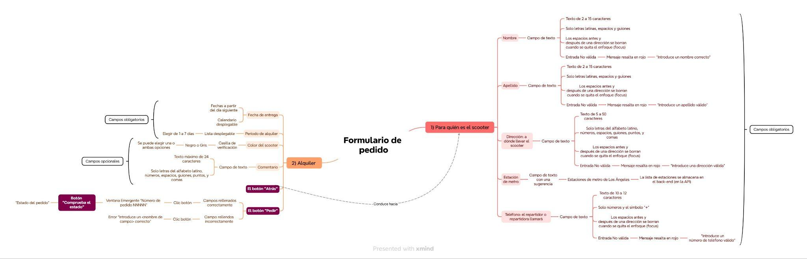

- Enlaces a los informes de errores creados en Jira:

https://pablosalomonn.atlassian.net/browse/S1T-4

https://pablosalomonn.atlassian.net/browse/S1T-5

https://pablosalomonn.atlassian.net/browse/S1T-6

https://pablosalomonn.atlassian.net/browse/S1T-7

https://pablosalomonn.atlassian.net/browse/S1T-8

https://pablosalomonn.atlassian.net/browse/S1T-9

https://pablosalomonn.atlassian.net/browse/S1T-11

https://pablosalomonn.atlassian.net/browse/S1T-12

https://pablosalomonn.atlassian.net/browse/S1T-13

https://pablosalomonn.atlassian.net/browse/S1T-14

https://pablosalomonn.atlassian.net/browse/S1T-15

https://pablosalomonn.atlassian.net/browse/S1T-16

Tarea 3: Aplicación móvil Urban Scooter

- Enlaces a los informes de errores creados en Jira:

https://pablosalomonn.atlassian.net/browse/S1T-17

https://pablosalomonn.atlassian.net/browse/S1T-18

https://pablosalomonn.atlassian.net/browse/S1T-19

https://pablosalomonn.atlassian.net/browse/S1T-20

Tarea 4: API de la aplicación Urban Scooter

- Enlaces a los informes de errores creados en Jira:

https://pablosalomonn.atlassian.net/browse/S1T-21.

https://pablosalomonn.atlassian.net/browse/S1T-22

https://pablosalomonn.atlassian.net/browse/S1T-23

https://pablosalomonn.atlassian.net/browse/S1T-24

https://pablosalomonn.atlassian.net/browse/S1T-25

https://pablosalomonn.atlassian.net/browse/S1T-26

https://pablosalomonn.atlassian.net/browse/S1T-27

https://pablosalomonn.atlassian.net/browse/S1T-28

https://pablosalomonn.atlassian.net/browse/S1T-29

https://pablosalomonn.atlassian.net/browse/S1T-30

https://pablosalomonn.atlassian.net/browse/S1T-31

https://pablosalomonn.atlassian.net/browse/S1T-32

https://pablosalomonn.atlassian.net/browse/S1T-33

